Postman result for Input:

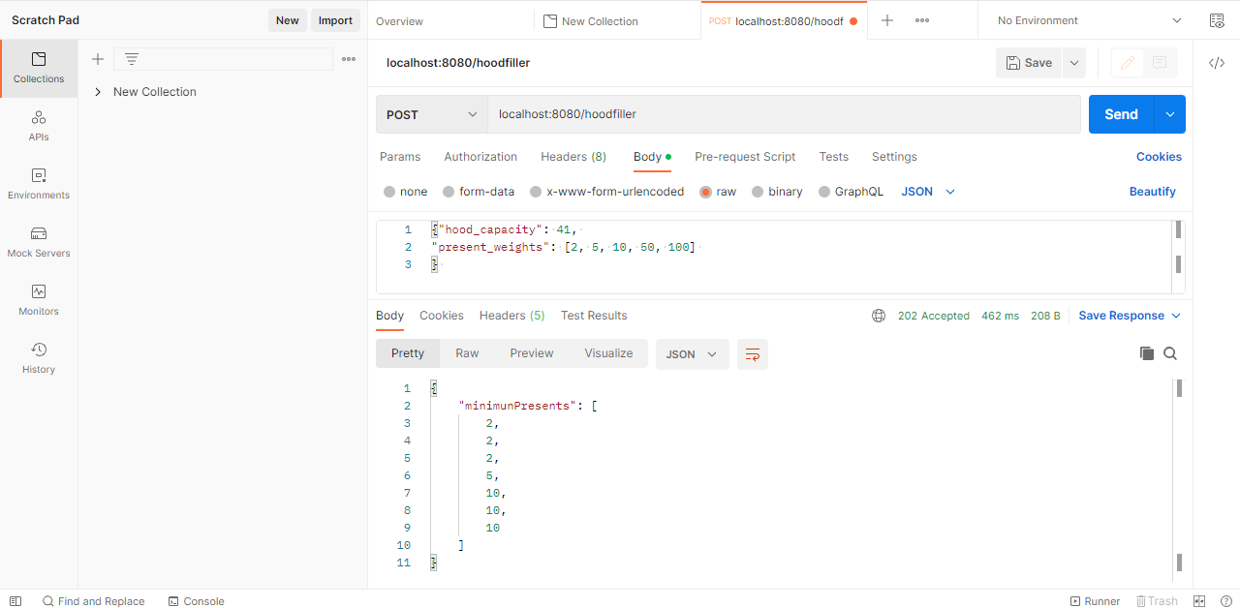

Result from Docker for the Container:

